Overview
From the Make a transport booking page you can make a new booking for travel to, or return travel from, a medical appointment. Making a new travel booking is a four step process.
When making a transport booking, fields marked with a red asterisk (*) are mandatory.

The Make a transport booking screen.
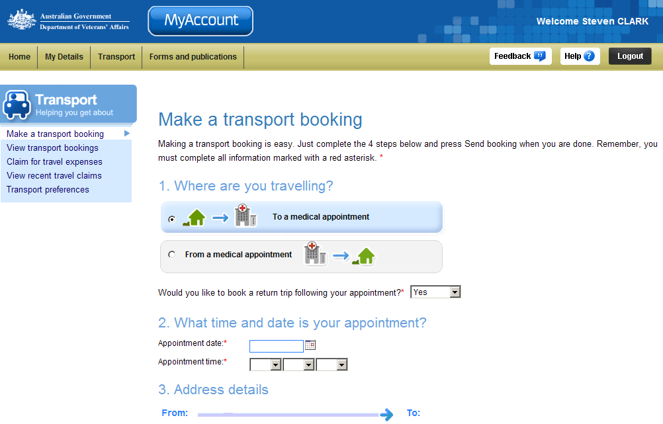
Transport menu
Four steps to make a transport booking

Make a transport booking to a medical appointment
To make a transport booking to a medical appointment:
- In the 1. Where are you travelling? section, select the first option, To a medical appointment.
 | The selected option and graphic is highlighted in blue.
- Would you like to book a return trip following your appointment will default to Yes, update if required.
Specifying Yes to booking a return trip means you only need to make one booking within MyAccount as the return booking is automatically booked at the same time.
- In the 2. What time and date is your appointment? section, in the Appointment date field, enter the date of your appointment.
When entering dates, you can use the calendar tool ( ) to select a date from a calendar.
Alternatively, enter dates in the format dd/mm/yyyy.
- In the Appointment time fields, use the drop down boxes to select the hour, minutes and ‘am’ or ‘pm’ time of the appointment.
When booking travel to a medical appointment, the Appointment time is the time of your appointment, not the time you want to be picked up.

The 3. Address details section.
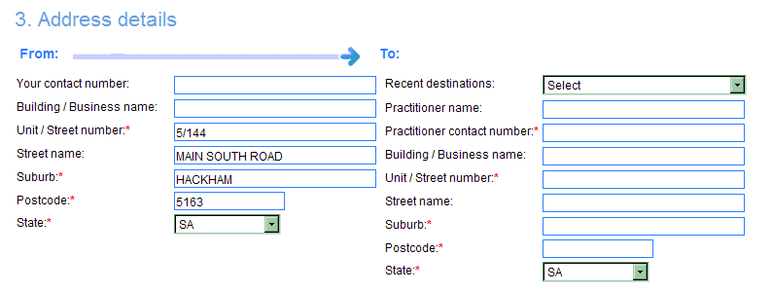
- In the 3. Address details, From section, your residential address, as displayed in MyAccount, is populated by default as your pick up location.
If required, edit the From address details and contact number.

For travel to a medical provider you have visited recently
- In the To section, click on the Recent destinations drop down box and select the medical provider from the list.
The To address fields will be populated automatically.

For travel to a medical provider you have not visited before
- In the To section, complete the contact and address fields for the medical provider you will visit.
- In the 4. Additional Information section, use the drop down boxes to provide answers to the four questions.
- In the Do you have any other special requirements… field, if required, enter details of any special requirements or instructions you feel it is important for the transport provider to know.
Information you may wish to provide, for example: steep driveway, call on approach, driver may need to assist veteran with stairs, etc.
These are notes for the transport provider only.
- Click on the Send Booking button.

The View transport bookings screen displays.
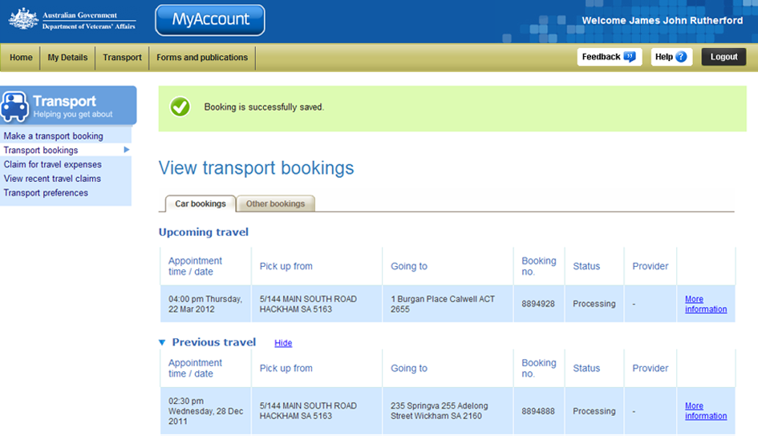
Upcoming travel section
At the top of the screen, a green success message states your booking has been successfully saved.
If you have specified Yes to booking a return booking the following success message will display:
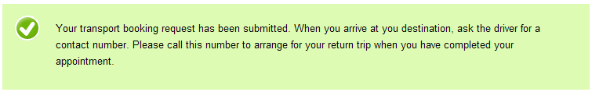

In the Upcoming travel section, details of your new booking are displayed.
If you have specified Yes to booking a return booking, both bookings will be displayed.

Other functions
 | To view another section or perform another transaction related to transport, click on a link in the Transport menu to the left of the page.
 | To get additional help with the Make a transport booking screen, click on the Help button at to the top right of the page.
 | When you are finished using MyAccount, to log out and finish using the service in a secure way, click on the Logout button.

